Design Specs
Spring 2012 Cycle 1

Note: As there may still be bugs that need fixing and the sound functionality to be implemented, this cycle will last only one week. Most of what is in this week’s specs are not new but a reiteration of what we had last semester.

Sound Integration
To reiterate what was included in the previous design spec for sound, the main points are listed below:

Both the main conference and side chats must have sound spacialization implemented. Once an icon is moved from point A to B on the screen, audio for that icon should be updated accordingly.

The default audio setting for moving from one side chat to another is that the previous chat’s volume will be muted. Therefore, unless the user changes the settings himself, the user will only hear audio from the main conference and the side chat it is currently in. The volume of the main conference (when the user is in a side chat) can be set to 50% of what is actually is.

Changing volume settings on the sound panel will allow the user to listen to more than one conversation. Although the UI for this has been implemented, there is an issue with scrolling through side chats. The sound bar should always scroll with the side chat it corresponds to. When you scroll through the sound bars the side chats should scroll as well to indicate which volume settings are being changed.

Sound from the other chats should be spatialized as well, however their volume should be reduced according to the sound panel when the user is not in them.

Side Chat preview
When a user taps on a side chat, a preview bar should show up with the contacts in the side chat. The preview bar is a horizontal bar across the width of the screen that displays icons of contacts in it and a stationary go button on the right. The user should be able to scroll through the contacts by swiping his finger from right to left.

Each user icon is 90x90px with the inner icon being 82x82px (centered horizontally and vertically). The colored overlay is centered horizontally and reaches 16px above the bottom edge of the user icon. Text is 11 point font and black for names and #f5f5f5 for admin bar. The admin bar is 15px in height. There is 5px between each user icon. Opacities for the icon, color overlay, and admin overlay are the same as what was specified for the normal user icons.

The preview bar is 100x480px and is 10px above the top edge of the side chat menu bar. It is solid black with opacity of 50%. The “go” button is 100x100px with opacity of 50% over the preview bar. The “go” text is 100% opacity off-white (#F5F5F5). Icons are on layer between back preview bar and go button. The bottom of the text is horizontally and vertically centered (40px from the bottom of the button and 25 px from the left of the button).

The pointer triangle is an equilateral triangle with all sides 38.5px with the height being 33.3 px. It will point to the center of the top of the side chat icon.

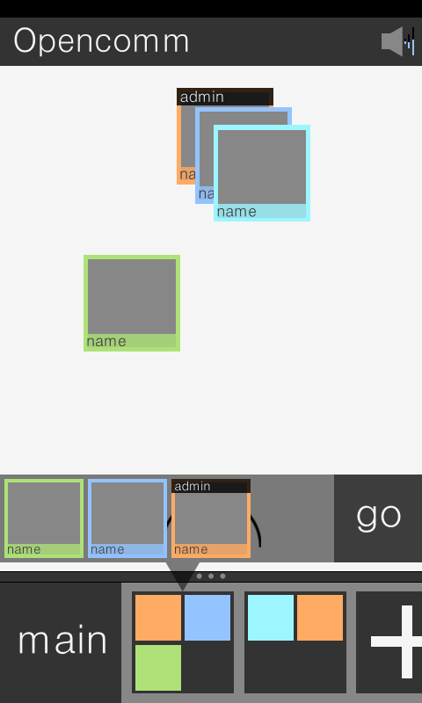
Figure 1 – what the preview bar should look like
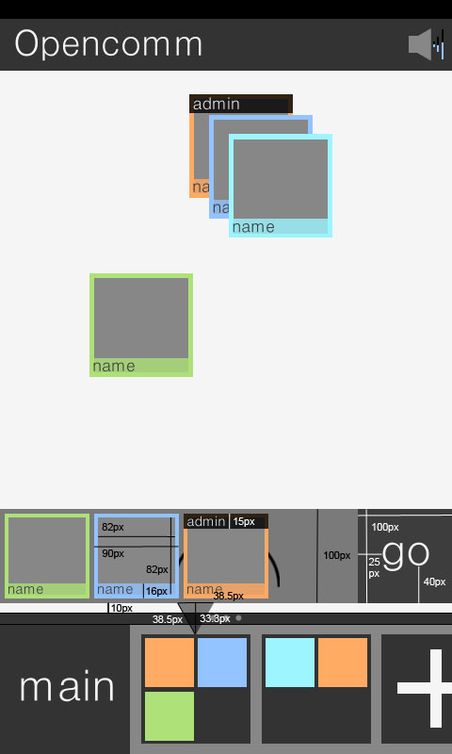
Figure 2 – preview bar with measurements

Deliverables:
- Sound spacialization within the main conference and each side chat
- Default sound settings should be in place
  - When in side chat, main conference should be set to 50%
  - Volume of previous side chat will be muted
- Sound panel
  - Implement horizontal scrolling
- Preview bar
  - Bar itself is 100x480px
  - 10px from top of the side chat menu
  - Solid black with opacity of 50%
  - Go button
    - 100x100px
    - black with opacity of 50% on top of preview bar
    - “Go” is solid #f5f5f5
    - text is in between button and preview bar
  - User icons
    - 90x90px
    - Inner grey square is 82x82px
    - Color overlay is 16px from the bottom, centered horizontally
    - 11px font
      - solid black for name
      - #f5f5f5 for admin
    - 5px between each icon
    - same opacity as regular user icon
  - Pointer
    - Equilateral triangle with side length 38.5px
    - Height is 33.3px

